If you have trouble viewing this email, you can view it online at
http://msgroups.tech.northwestern.edu/esw/about.html

The ESW Circular
Engineers for a Sustainable World, Northwestern University Chapter www.eswnu.org |  |  | November 18, 2006 Volume 1, Issue 2
In This Issue  Panamania!! (okay, you knew that one was coming up eventually)  The Ecomagination Challenge  ESW Potluck!  Sustainability in the News  Amazing Art Exhibit | ESW Goes Green(er) | 
Hey ESW fans. It’s me, Tom Cohlmia, reminding you that there is no “I” in “solar panel.” So, just the other day I got an e-mail from a lovely woman at ESW National named Leti McNeill. She wooed me with compliments on our new format and slyly hinted that we use the new logo (above – isn’t it smashing?) and change the color scheme to match the brand new official ESW colors. What can I say, I’m a sucker for compliments.
The switch from light bulb in the logo was apparently made because the cog is the most widely recognized symbol of engineering. While blatantly giving the cold shoulder to those electrical engineers in our midst (sorry, Eric), I as an old-fashioned ME say it’s great. (By the way, for an amazing “Cog” video and proof that engineers rule, go here.) I dig the new colors too, despite my initial trepidation with mixing orange and green. All right, off we go!
  Okay, give me a break. I’m an engineer, not a graphics designer. | Panamaniacs!
 | Great news! We have a confirmed team of ESW explorers who will be heading to Panama this December! Say congrats to Eric Lai (Yakko), Ankur Asthana (Wacko), Laura MacDonald (Dot), and Jennie Kessler (Helooooo Nurse!). They’ll be hitting the dusty trail – and by dusty trail I mean international flight - soon after finals, where they’ll continue work on our previous projects, as well as possibly start a few new ones. (And bring back my laptop, hopefully.) They’re ALWAYS looking for help at a wide range of involvement and knowledge levels (from writing grants to building – what was it you’ve got me making now, Jennie?), so if you want to help out, e-mail the lovely Nurse Jennie at jen.kes@gmail.com. |  |  |   Jennie
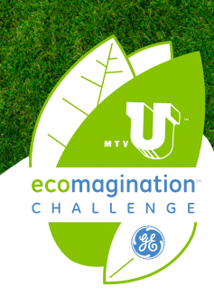 | The MTVU Ecomagination Challenge
One thing that ever ceases to amaze me is how cool sustainability has gotten recently. In the MTV generation, the electric car was a nerd-mobile – now MTV’s gotten on board and paired up with GE to make one heck of a hoot ‘n’ holler about sustainability on university campuses.
The Ecomagination Challenge is an idea contest – who can come up with the best, coolest, most innovative way to make their campus more socially responsible. The winner gets the cash to actually implement the plan (up to $25,000), plus an MTVU concert on them. And we’re going for it!
Aaron Greco (greco@northwestern.edu) is heading up the group to present a sustainable transportation system – one that runs on used grease. The University dining halls generate 150 gallons of waste vegetable oil every month, and they often have to pay to have it taken away. Instead, we want to use it to power all the shuttles on campus, and possibly even the SafeRide cars too. It’s a win-win for everybody! If you want to get involved, speak up soon: the application is due December 1st so we’re in high gear to get the proposal finished in time. E-mail Aaron (greco@northwestern.edu) for details.
 | Potluck at Chez Eric
 | So, I know this is really short notice, but I might as well mention it: there’ll be a kickin’ potluck to celebrate the end of another successful quarter of ESW awesomeness. It’ll be at Eric Lai’s place at 6:00 on Monday the 20th (right, tomorrow). Bring food, a sense of humor, and any party tricks. We’ll be watching “Who Killed the Electric Car?” too, so bring some popcorn. For directions and details, e-mail Eric at e-lai@northwestern.edu.
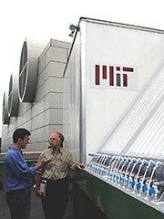 | Sustainability in the News
Colleges are the place to be for sustainability these days; we’re an entire generation that’s motivated to change the world. MIT’s doing some interesting stuff with reducing CO₂ emissions with green goop; they’re bubbling waste CO₂ through giant vats of algae, which eat it up to grow. Best of all, the algae itself can be used as fuel in power plants! Read about it here: http://web.mit.edu/erc/spotlights/alg-all.html.
Greening of campuses has also been a big deal of late, and it’s been gaining momentum: just this week, a huge group of colleges and universities committed to greening their campuses! Sadly, NU wasn’t on that list, but we’re already in pretty good shape: Northwestern is committed to having twenty percent of its energy come from renewable resources, along with a host of other good things. To read more about the other schools, go here: http://www.renewableenergyaccess.com/rea/partner/story?id=46505
To see Northwestern’s current sustainable commitment, go here: http://www.northwestern.edu/fm/environmental_sustainability.htm.
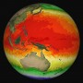  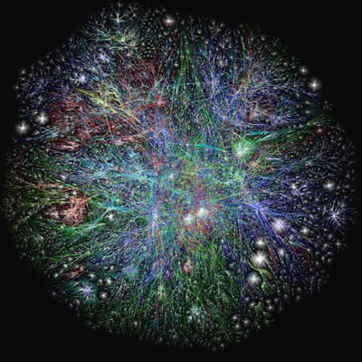 | Massive Change at the MCA
Right now at the Chicago Museum of Contemporary Art, there’s a really amazing exhibit called Massive Change. It’s about the ability of humans to adapt in response to skyrocketing population and scarce resources. Sound like something more for the science museum? Think again. This show is flat-out amazing: my Co-Chair Margaret and I went about a month ago, and it was phenomenal. Professor Gray took her sustainability class, and just this weekend was a symposium on the exhibit that some of our members attended.
So go! Admission is $6 for students most days, free on Tuesdays with a student ID; you can easily take the El, or NU’s inter-campus shuttle picks you up right on campus and drops you off a mere stone’s throw from the museum. The exhibit runs until the end of December.
As John Lennon once said, “we sailed up to the sun ‘till we found a sea of green, and we lived beneath the waves in our yellow submarine.” Powerful words. Anyway, hope you’ve had fun reading this issue. We’ll be on break…starting now, really. No newsletter in December, no more meetings until January – not to say we won’t be working like crazy on grant writing, planning for Panama, building things in the shop, and generally saving the world. We’re cool like that. If you can help with any of that, please e-mail somebody – pretty much anyone in the above list will do. But have a fun break, good luck with finals, and talk to you later! If you start to pine for sustainability talk over break, e-mail me at t-cohlmia@northwestern.edu and I’ll keep you entertained.

As always,
Tom

 | Shop and Support Us at no additional cost to you  Shop at your favorite online stores such as Amazon, Apple, Macy's and a percentage of your purchases will directly benefit ESW-NU. Going to buy books? Need a gift or more great music? Go online at http://eswnorthwestern.freepledge.com and donate to ESW-NU at no additional cost. No obligation, no membership, no hassle.

