If you have trouble viewing this email, you can view it online within 24 hours after release at
http://msgroups.tech.northwestern.edu/esw/about.html

The ESW Circular
Engineers for a Sustainable World, Northwestern University Chapter www.eswnu.org |  |  | January 15th, 2006 Volume 1, Issue 3
In This Issue  Start the Year Off Right!  Panamaniacs Return!  ESW in the Classroom!  Be a Sustainability Star!  Global Warming in the News! | Happy New Year! | 
 | Well, I’ve made it another quarter without being strangled by my oh-so-amicable co-chair Margaret Adsit, so I must be doing something right. Tom Cohlmia here, reminding you to eat your black-eyed peas at the new year for good luck. 2006 was an exciting year for sustainability awareness: movies like An Inconvenient Truth and Who Killed the Electric Car made normal people get up in arms about global warming; hybrid cars became fashionable; and believe it or not, Wal-Mart made a push to go green. It’s enough to make the fanatics think we may even survive the impending global warming catastrophe… just kidding, guys. And now, on with the show!
 | Winter Kickoff Meeting!
 | Are you ready for an amazing start to the quarter? Worried you’ll settle into the same old routine? Well no more! Come to ESW’s Winter Kickoff Meeting to get ready for a quarter of amazing projects. Come to LR5 in Tech at 5:00 on January 15th (Monday) to see what ESW’s been up to, what we’re doing next, and fulfill your New Year’s resolution to be more involved on campus! Delicious food will be served. See you there!
  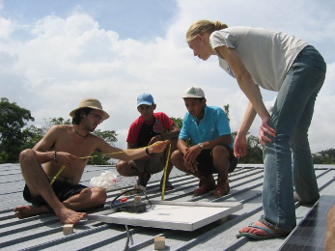  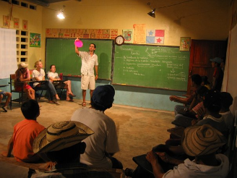  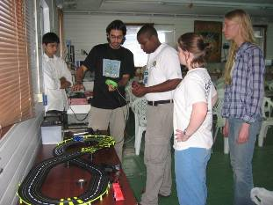  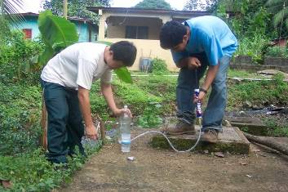  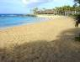  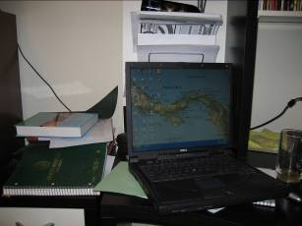 | Panamaniacs are Back!
This issue of the Circular will regale you with tales of our wacky band of adventurers the Panamaniacs (Jennie Kessler, Eric Lai, Ankur Asthana, and Laura MacDonald) and their trek through Panama in the name of sustainability. Along the way, they were helped by our old friend Adrian Jinich, who “went native” shortly after graduating and has been wandering Central America ever since.
Santo Domingo
Their first destination was Santo Domingo. We’ve been working with this small ranching community for the last year now installing solar panels. This time the ESW crew put up a solar lighting system in the community school and held a meeting in the newly lit room. The school is planning to hold night classes and raise money by letting people charge their batteries with the panels. Our team also put up some panels on a nearby church and made repairs to existing fence chargers. This was ESW-NU’s last trip to Santo Domingo, so the parting was a sad one. Still, ESW’s partner in the project, CEASPA, is sending members back periodically to check on the systems, and I’m sure we’ll come visit when we’re in the neighborhood.
Galeta
Next, the ESW team stopped off in a small coastal research facility called the Galeta Marine Laboratory. One of the researchers (don’t ask how) got ahold of us, and long story short we set up a solar-powered toy car racetrack. They even got interviewed to be on the news, although Adrian did most of the talking – you know, so they could understand what we were saying and all.
Portobelo
Finally, they ended in Portobelo and continued working on plans for the water treatment facility. Did some purity tests, surveyed potential sites for a sludge-drying bed, and toured the city’s septic tanks. They also spoke with the locals and fond people interested in working to empty the current septic tank system as a temporary solution until a real plant can be constructed.
The biggest news of all is this: I GOT MY LAPTOP BACK!!! Yes, after being passed around the Colon province for three months, it finally made its way back to the states and into my loving arms. It’s nice to know I helped out, but a little disheartening to know that my computer is now more well-traveled than I am. It’s been acting funny, too. It lingers somewhat wistfully on photos of the trip, spontaneously opens Travelocity pages on flights to Central America, and the fan whirrs with a Spanish accent.
 | The Panama Connection
 | Even though we’re back from Panama, we brought the projects back with us. Two IDEA 398 groups are hard at work on parts of the Portobelo wastewater project. The first, composed of Jennie Kessler (Helooooo Nurse!), Laura MacDonald (Dot), and Carlos Lema (um… Carl?), is working on the treatment plant setup. Then there’s Jared Stratum, Julia Padoiskis, Umar Noonetoldmehislastname, and Linda Buzzi, who are hard at work devising a method for emptying the current septic system. Jennie would probably be the best person to contact to learn more, so drop her a line.
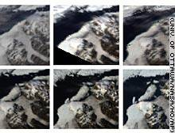  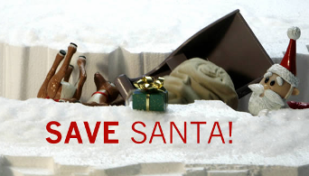 | Sustainability in the News
I got an e-mail over break from my predecessor Angela Han. She complimented the newsletter and suggested a news story, and as you all know I’ll do anything for compliments. Besides, she and I are old buddies: we did a Mat Sci report together on why the Titanic sank (Answer: it hit an iceberg). She sent me this article about a huge ice shelf collapsing because of global warming.

Oh, and in the spirit of the season, I absolutely have to show this video. Happy Holidays.
 | I’m Ready for My Close-up, Rahul…
 | Your inimitable Education Chair Laura Pigion has been hard at work making sustainability the word on everyone’s mouths. She’s planning a side-splitting, witty, yet wholesome and informative video on conservation that we’re going to broadcast to the world. We’re trying to work with film students, comedy groups, and other pros of the trade to make this the next number 1 video on YouTube. The script is already in the works, so if you want a piece of the action, be it writing or starring, let her know.
I like my sustainability projects the way I like my newsletters: well-thought out, purposeful, and fun. I think ESW does that, and I at least make a fair go at it too. If you disagree, tell my co-chair Margaret; I don’t think I could take that kind of rejection, and she’ll let me down easy. If you liked it though, let me know: my record shows I’ll do anything for someone who compliments the newsletter. Until next time, remember: a Darrieus wind turbine is not a toy. (But I still want one.)
As always,
Tom

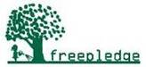 | Shop and Support Us at no additional cost to you  Shop at your favorite online stores such as Amazon, Apple, Macy's and a percentage of your purchases will directly benefit ESW-NU. Going to buy books? Need a gift or more great music? Go online at http://eswnorthwestern.freepledge.com and donate to ESW-NU at no additional cost. No obligation, no membership, no hassle.

