Your SWE Exec Board:

President:
Sara Salahi
External VP:
Eric Huang
Internal VP:
Nina Bhatti
Program Director: Laura MacDonald
Program Chair:
Sarah Pilewski
Outreach Director:
Kelly Luckasevic
Outreach Chair: Annalee Embry
Treasurer:
Clara Smart
Fundraising Chair: Liz Hohl
Social Chair: Stephanie Schwartz
Secretary:
Jessica Frey
Alumni Chair:
Sharla Rent
Freshman Coordinator:
Jenn Breger
Tech Director: Veronica Park
Publicity Chair: Stacy Devino

Society of Women Engineers
Northwestern University Section

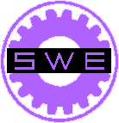

Fall Newsletter
September 26, 2006

Thanks to everyone who attended and helped make the New Student Week Brunch a success! We had over 50 new freshmen in attendance.

New Student Week Brunch

The SWEeties of Northwestern University are proud to host the 2007 Region H Conference. The conference will be held January 26 through 28, with activities in Chicago as well as on campus in Evanston, Illinois. We are so excited to welcome Barb Samardzich an executive director of Ford, as one of our keynote speakers, in addition to several other influential women speakers. The career fair on Saturday afternoon will include dozens of companies including Ford, Caterpillar, and The Boeing Company; all interested in talking to bright female engineers! In addition to general region events, conference attendees will have the opportunity to participate in social events in downtown Chicago such as ice-skating in Millennium Park. The cost of attending this conference is $25 for current SWE members. If you have not updated your SWE membership for the 2007 fiscal year, please do so at www.swe.org. We look forward to seeing you all in SWEet Home Chicago, January 2007!

2007 Regional Conference
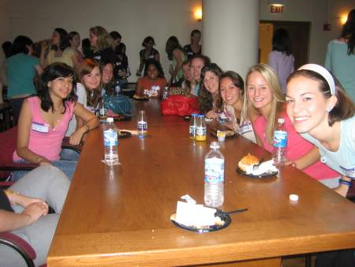

Important Dates

National Conference:
October 12-14

Industry Day:
October 19

Next General
Meeting:
October 24

What did you do this Summer?
We compiled a list of internships SWEeties had this summer. Interested in their major or company? Ask how it went!

Laura MacDonald: Environmental Engineering, AEI Consultants
Jessica Frey: General Motors, Project Engineering
Sara Salahi: Summer Research Associate, Medtronic, Inc.
Sarah Pilewski: UOP: Pilot Plan Operation Group, Research Dept.
Kelly Migliazzo: Raytheon Company, Space and Airborne Systems
Julia DesChenes: Enel Latin America, Costa Rica
Hannah Durschala: Camp Kaleidoscope
Shonali Midha: Research, Weill Cornell Medical College
Stephanie Olsen: General Motors, IE Department
Samantha Gordon: Proctor and Gamble, R&D Family Care, Bounty Franchise
Amanda Cordova: Abbott Laboratories, Global Pharmaceutical Operations
Susie Overbey: General Intern, Peel, Inc.
Jenny Fung: Research Assistant, Lims Lab, Northwestern
Shannon Binder: Analyst, Accenture
Brittany Tarvin: Procter & Gamble, Product Supply Operations
Nina Bhatti: Alllstate Insurance Company, Enterprise Technology Service
Kelly Luckasevic: Carnegie Mellon Univserity, Mat Sci Research
Sharla Rent: Public Health Study Abroad Program, Mexico
Jessie Donato: MetroHealth Medical Center, Chester Summer Scholar
Michellle Lee: Center for International Rehabilitation, Education/Learning Dept. Intern
Hristina Hristova: Cinta, Chicago Distribution Center
Joni Stegeman: Ethicon Endo-Surgery, Quality Co-op in R&D
Annalee Embry: Summer Career Experience Program, Vermont Forest Service

We’re on the Web!
See us at:
msgroups.tech.northwestern.edu/swe/

